Name : Harshith Gangisetty  
Task -01

Scanning m router for open ports

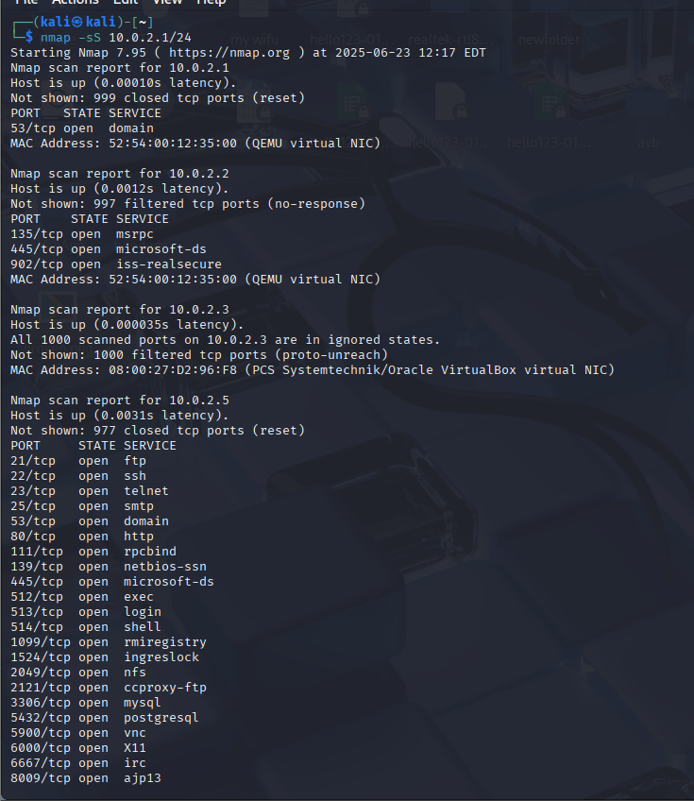

Found many open ports :

1. FTP port : this could be vulnerable to many attacks , even dangerous if anonymous login is allowed
2. 80 - http port : The information is sent in plain text